Tenda -- How to configure your computer before setting your router

- Right click Network Connection Icon on the system bar, then click on “Open Network and Sharing Center”.

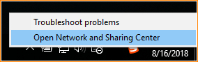

- Click on “Change Adapter Setting”.

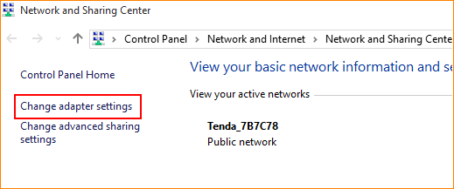

- Right click on “Local Area Connection”, and then choose the Properties option.

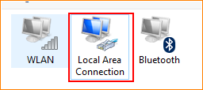

- Double click on “Internet Protocol Version 4(TCP/IPv4)”.

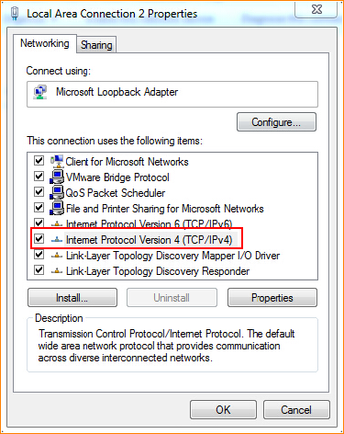

- Choose “Obtain an IP address automatically” and “Obtain DNS server address automatically” and then click “OK”.

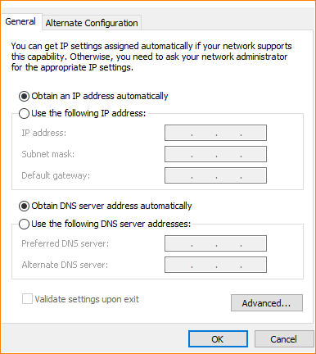

- Also click “OK” at the last window of Local Connection Properties.

